Send an alert notification when an EC2 instance gets changed from its state.
(Note: Include all state of the instance)
Send an alert notification when an EC2 instance CPU Utilization was idle for past 5 minutes.

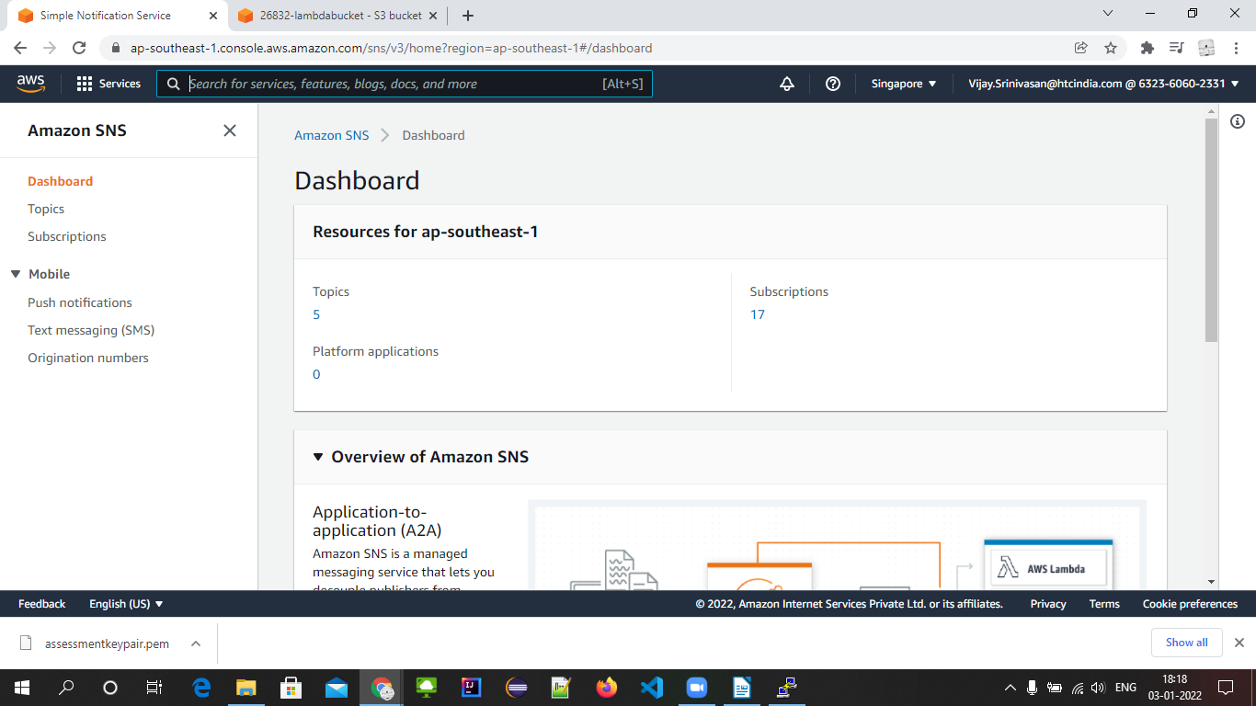
create the topic
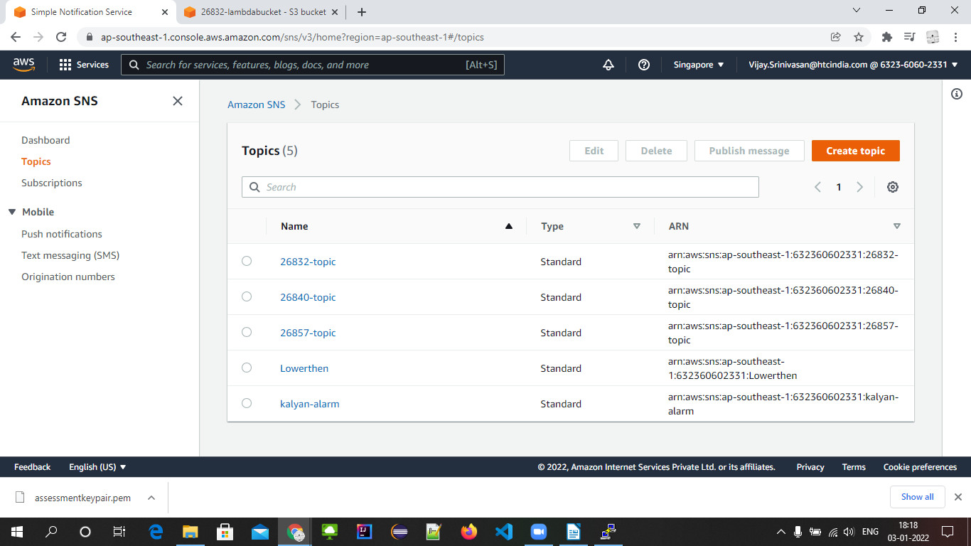
Filling details
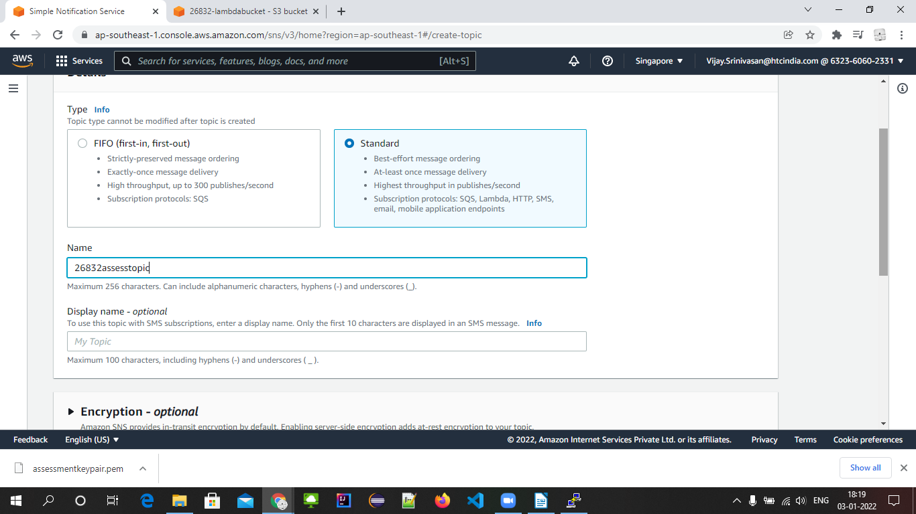

Topic created successfully
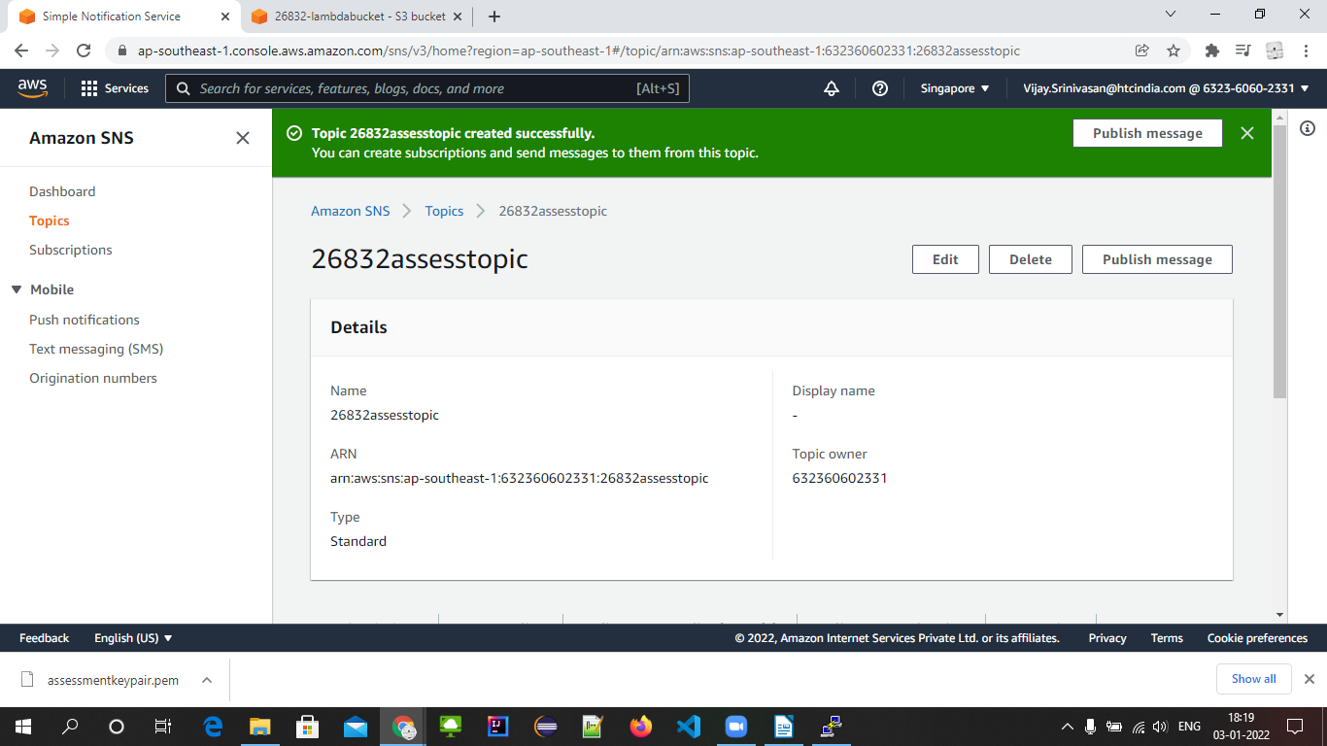
Creating subscription
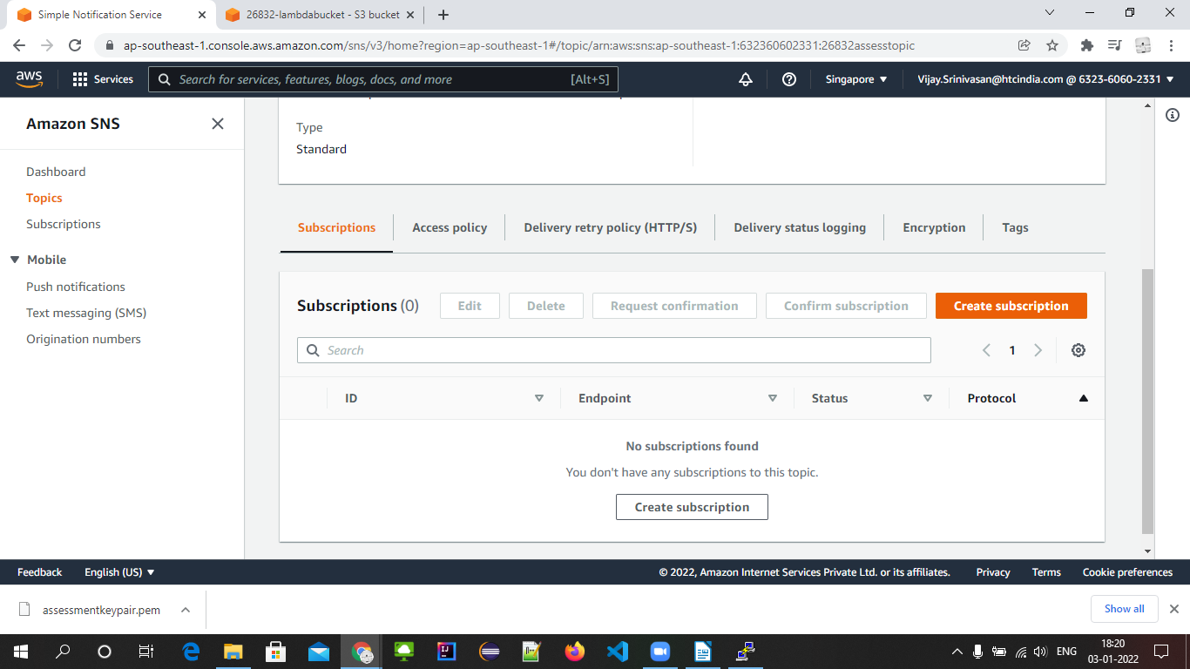
Filling details
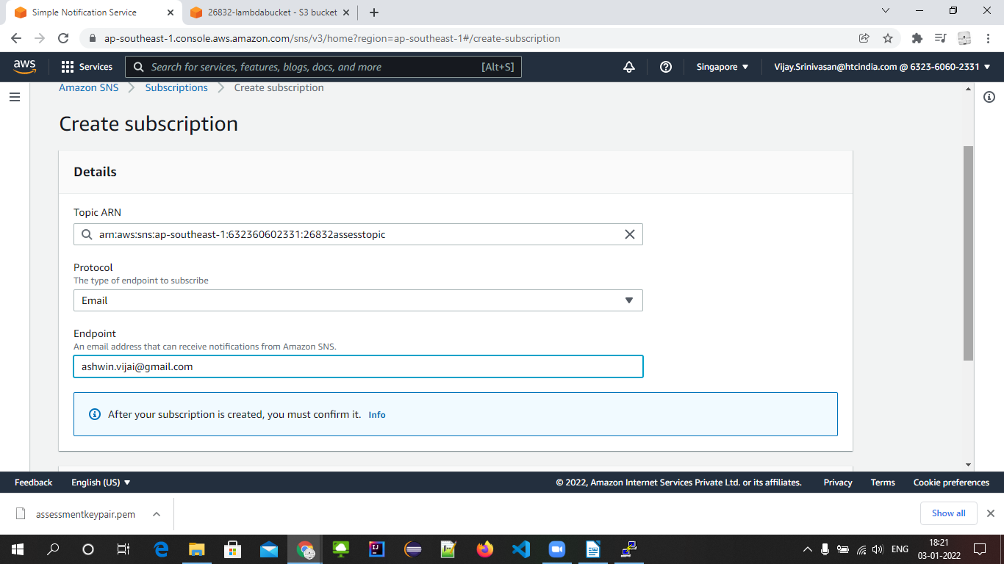
Created the subscription
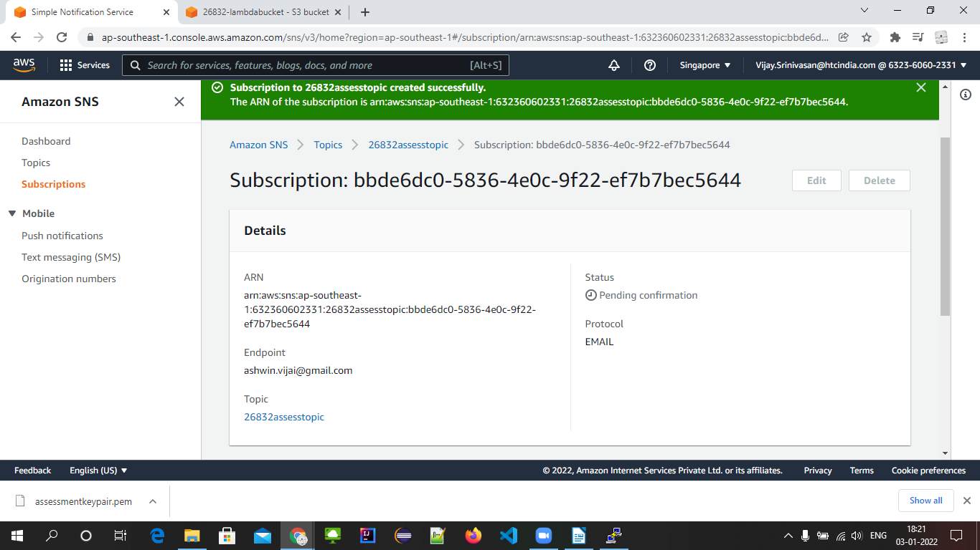
We have to confirm on the email
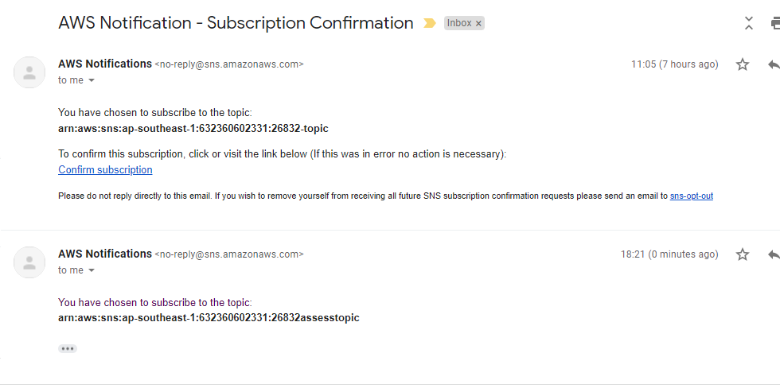
After confirmation
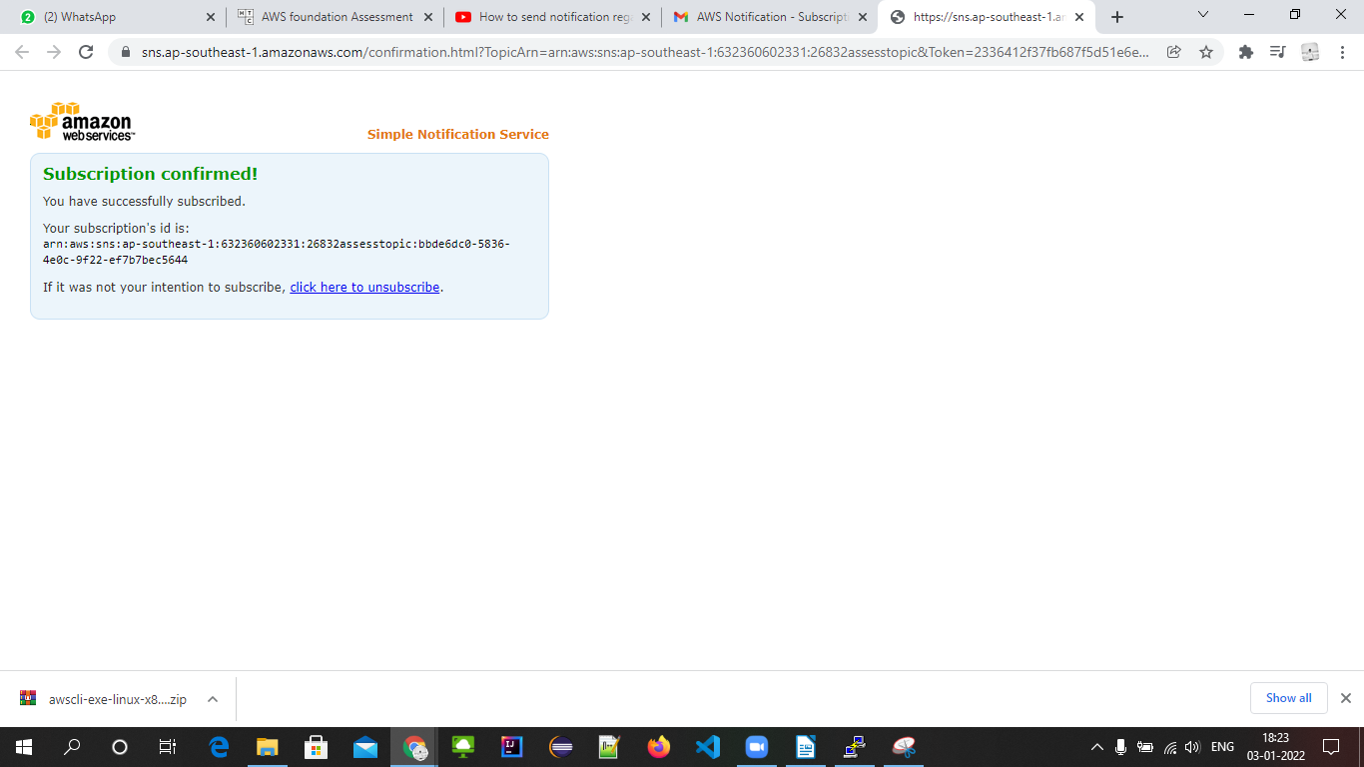
Status will be confirmed
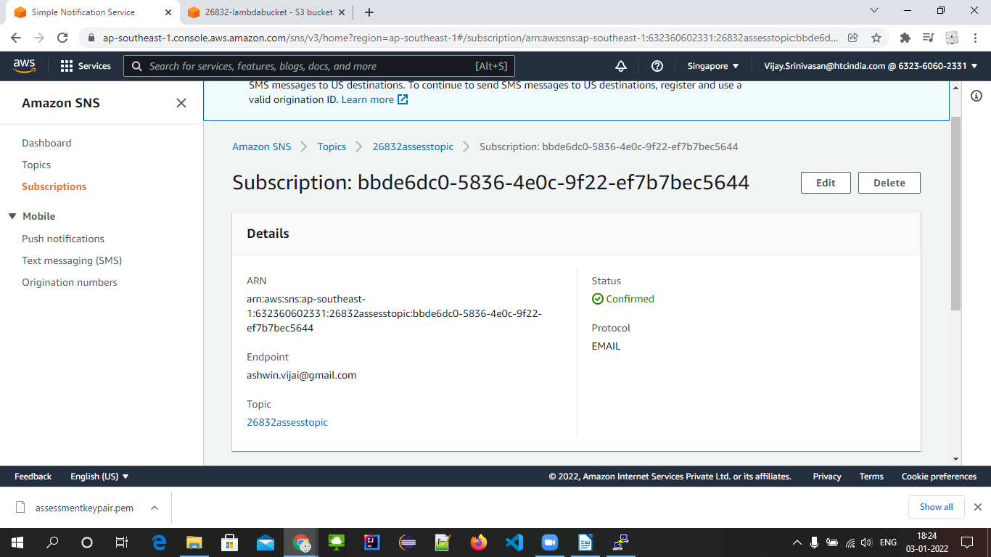
Opening cloudwatch
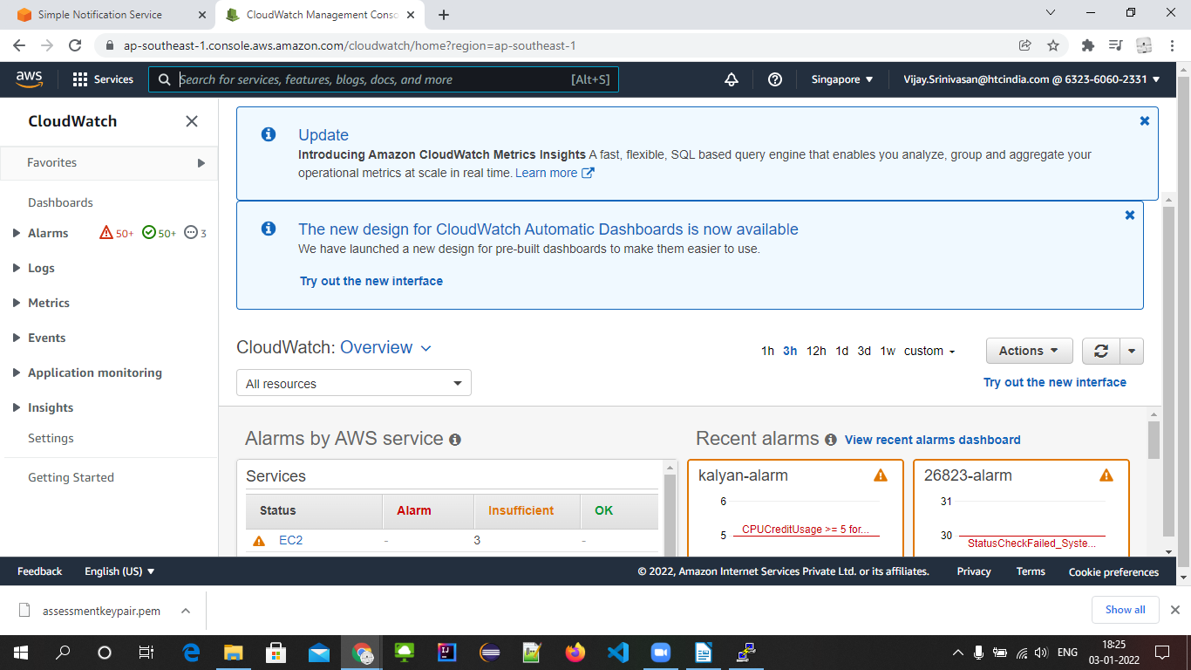
In events and rules from cloudwatch, creating rule
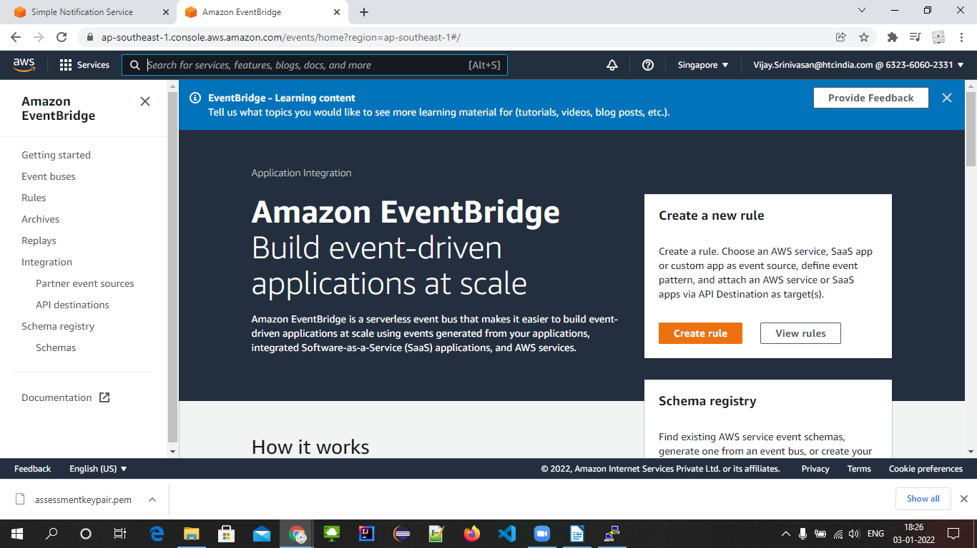
Selecting event type
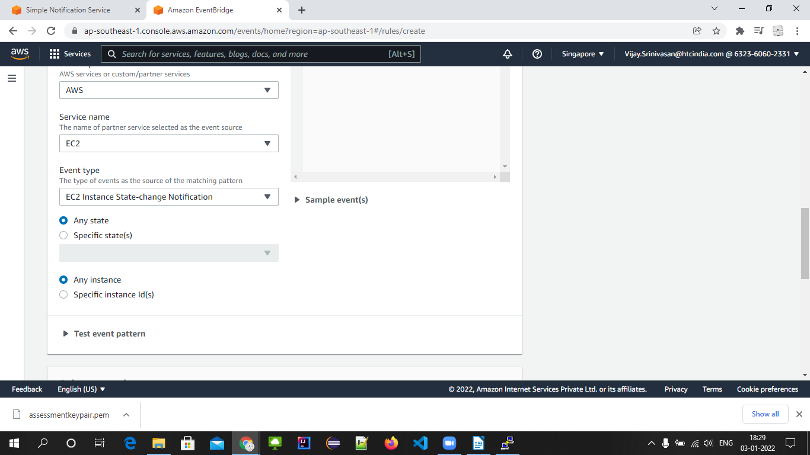
Selecting sns topic here
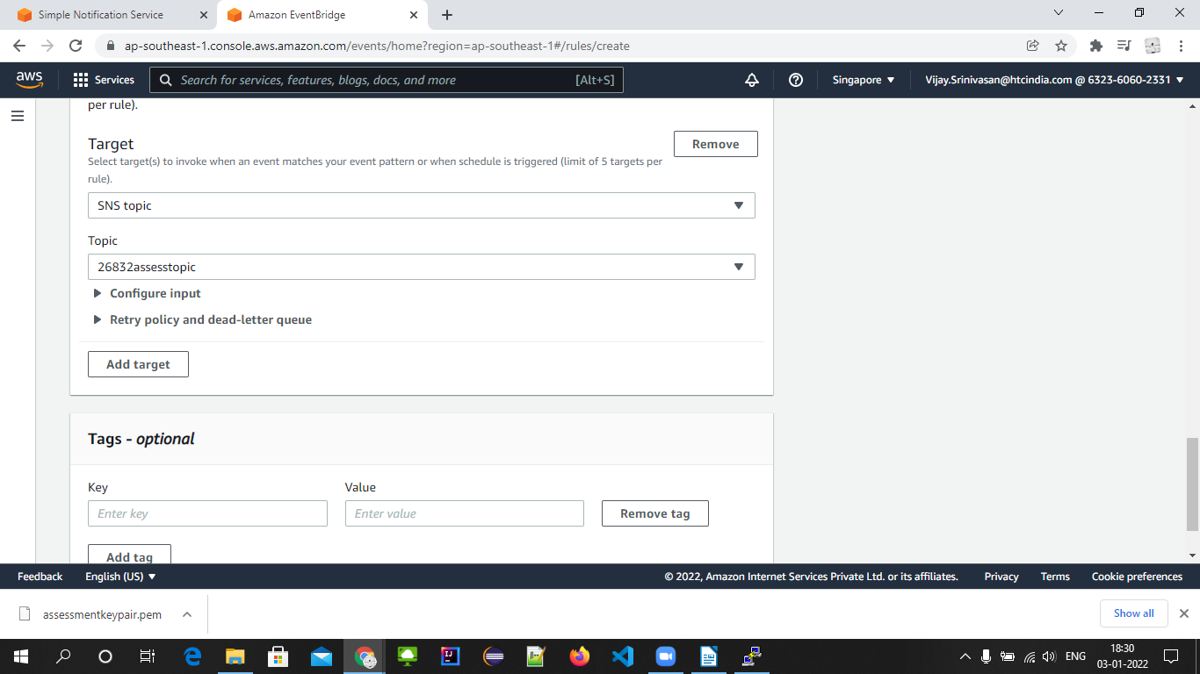
We’re creating the rule for every instance state changes. On every state change, we get a notification in our email.

